Mid Grampian Mesolithic Field Notes 2025

BLACKHILLOCK NH1 19/1/25
North East NJ 68043 17109
South East NJ 68111 16652
South West NJ 67851 16672
North West NJ 67839 17060
Area 10.5 ha
Canmore nil in this field
Aberdeenshire HER nil in this field
BGS Bedrock Bennachie pluton
BGS Superficial Upper 10% Banchory Till
10-80% Glaciofluvial sheet deposits
Lower 20% Alluvium – clay silt,sand, gravel
Underfoot Well weathered, heavy frost -> frozen surface, only thawed slowly during morning.
Soil Gravelly, stony upper areas, lower parts soft, muddy, silty.
Weather Sunny, clear, -2 rising to 5’C
No. of Volunteers 25, (2 families) , walked W-E with furrows. End rig not walked.
Lithics 127
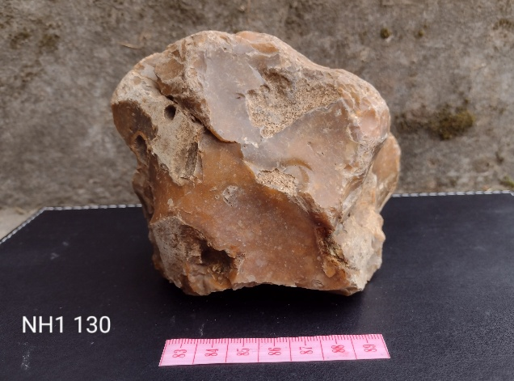
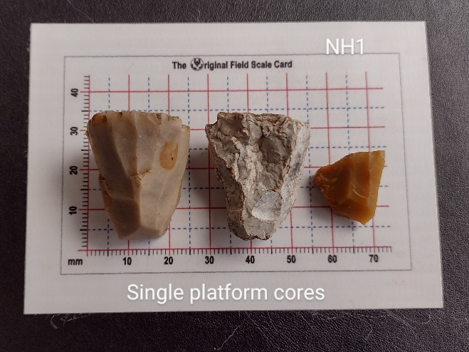
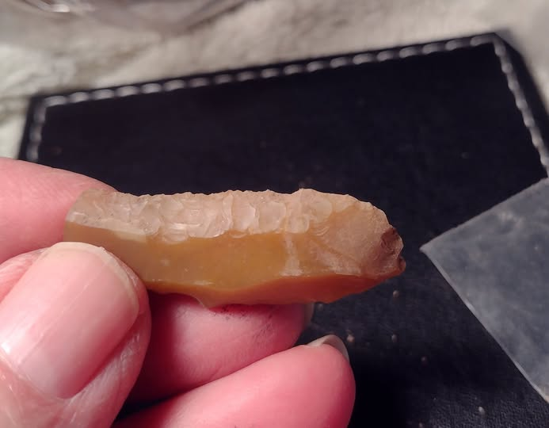
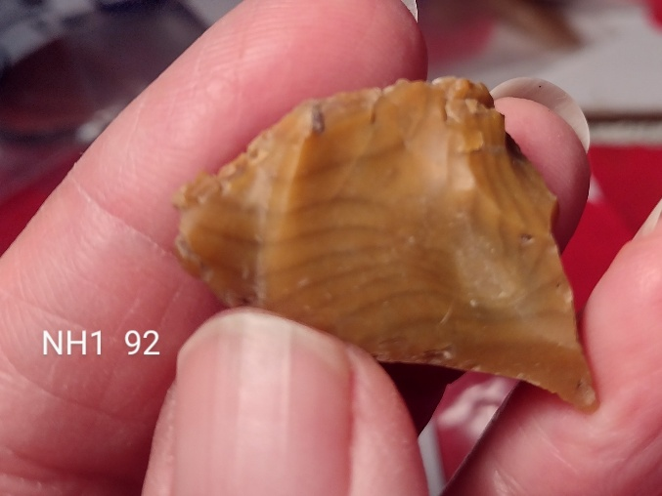

Blackhillock NH1

Camp Field CM1 25/1/25
North East NJ 71566 16348
South East NJ 71452 16015
South West NJ 71327 16047
North West NJ 71407 16466
Area 8.5ha
Canmore nil in this field
Aberdeenshire HER nil in this field
BGS Bedrock Tillyfourie pluton
BGS Superficial Upper corner - Banchory Till
To halfway down field – Glaciofluvial sheet
Lower half – Glen Dye silts
Underfoot Very well weathered to the extent it was difficult to see furrows and maintain direction.
Soil Upper areas gravelly, lower parts muddy with few stones.
Weather Cold wind, mainly dry and bright sun.
No. of Volunteers 8, walked N-S with furrows
Lithics 17
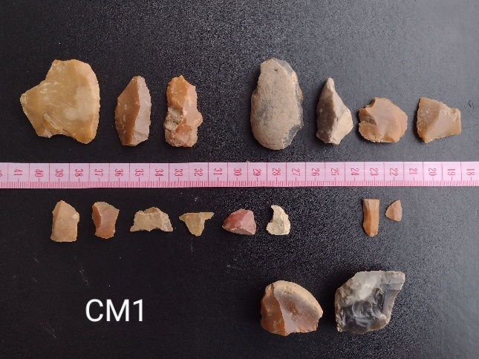
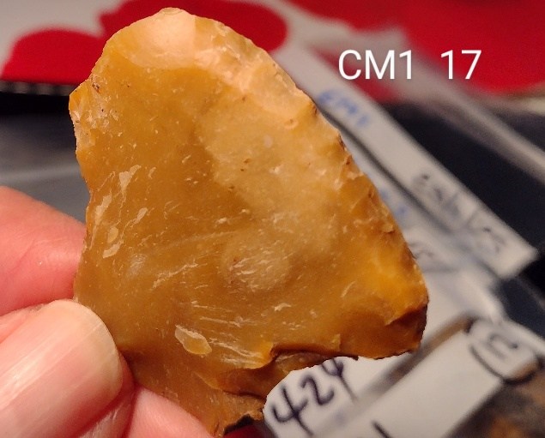
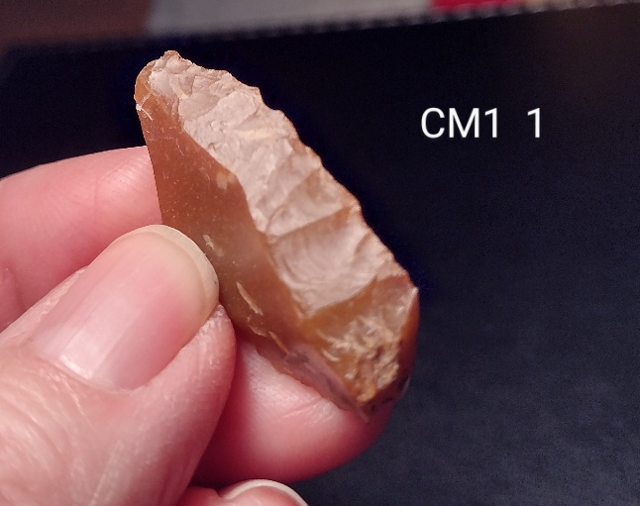

Camp Field CM1

School Field SF1 2/2/25
North East NJ 68265 15586
South East NJ 68129 15320
South West NJ 67715 15246
North West NJ 67727 15408
Area 9ha
Canmore / HER Nil in this field.
(NJ 6835 1543) A carved stone ball 2 3/4" (70mm) in diameter found 'when digging for new School at Monymusk' was lent by W Moir Bryce, for display at the Scottish Exhibition, Glasgow in 1911.
It has many small hemi-spherical knobs.(See also NJ61NE 12).

BGS Bedrock Tillyfourie Pluton - Foliated tonalite and foliated granodiorite. Igneous bedrock
BGS Superficial Most - Banchory Till Formation - Diamicton. Sedimentary superficial deposit.
Central ridge - Hummocky (moundy) Glacial Deposits - Diamicton, sand and gravel.
Underfoot well weathered, muddy
Soil Most good loam but stoney on central ridge
Weather dry, overcast
No. of Volunteers 22, walked E-W with furrows.
Lithics 99
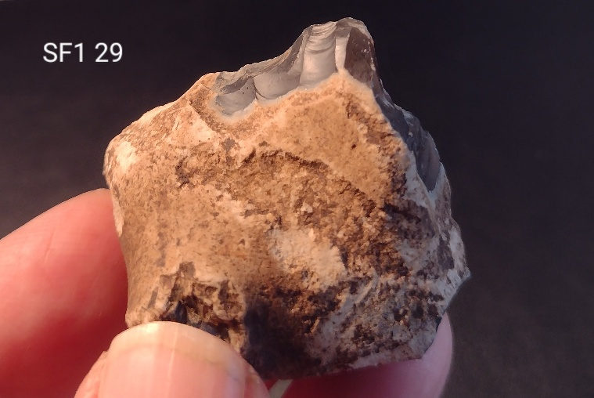
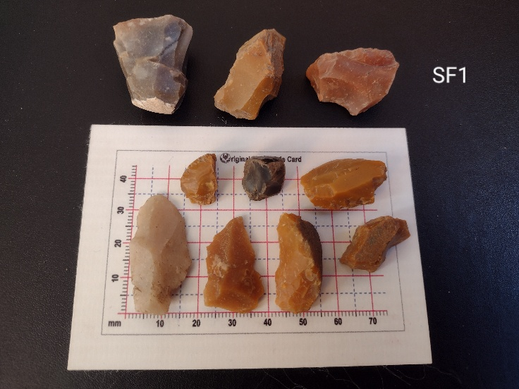
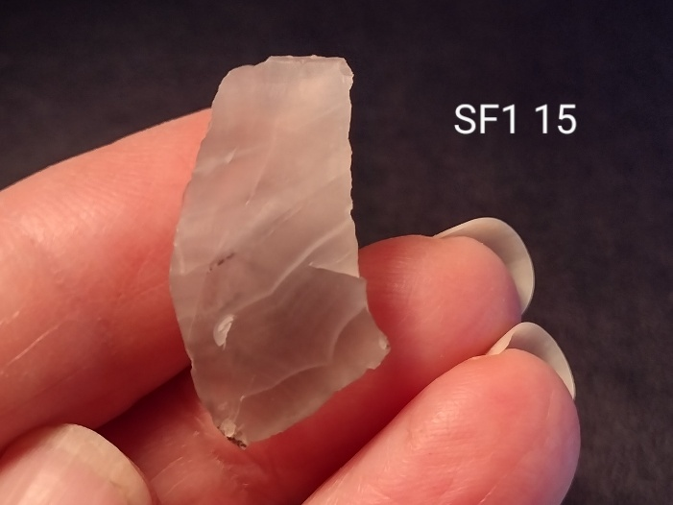
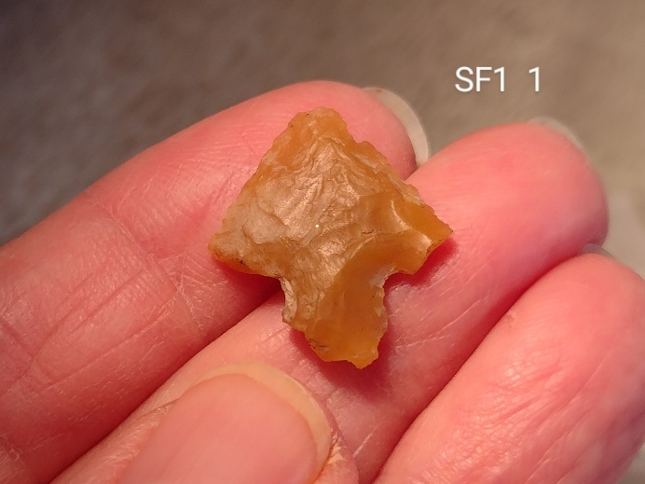

School Field
Nothing very Mesolithic about SF1. Loads of flakes and chunks. There was a Mesolithic platform core but really no blades to speak of. A nice scraper and one or two well worn scrapers, maybe a knife and a borer/awl most likely all Neo and of course the rather scruffy looking B&T. I'm pretty sure No 15 is an agate flake.

Bogs, Fetternear, Kemnay BOG1 8/2/25
North East NJ 71575 17016
South East NJ 71631 16680
South West NJ 71206 17006
North West NJ 71192 17103
Area 7ha
Canmore/HER Rig & furrow at various points in the periphery of the field.
B&T arrowhead in field to the west.
Along track at north edge records of crofts of Widow Sowdin and Jean Sim.
BGS Bedrock Tillyfourie Pluton - Foliated tonalite and foliated granodiorite. Igneous bedrock
BGS Superficial Glaciofluvial Sheet Deposits - Gravel, sand and silt.
Underfoot Well weathered, to extent furrows almost invisible. Surface frozen initially, later muddy.
Soil Upper areas quite stoney, lower areas patches of clay and few stones.
Weather cloudy, showery.
No. of Volunteers 11, walked W-E with furrow pattern.
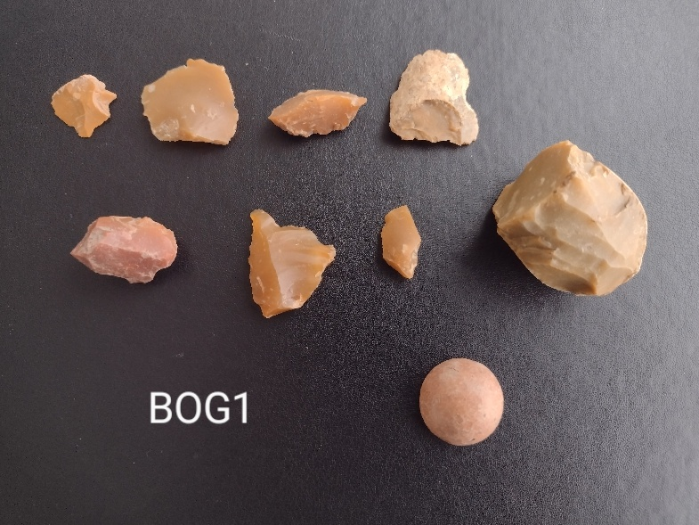
Lithics 8

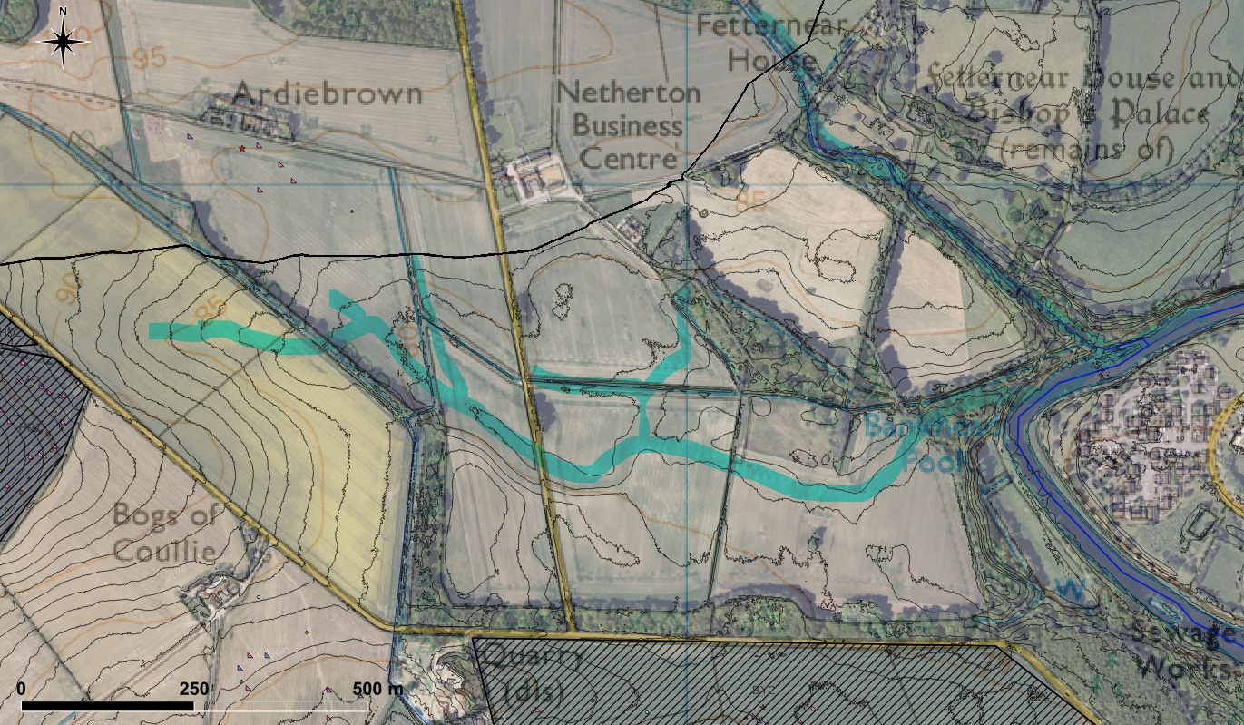
Bogs – contours suggest paleao stream running through SE corner of field. All finds on higher ground to north.

Walled Garden Field, Monymusk House, MM1 16/2/25
North East NJ 69181 15175
South East NJ 69239 14969
South West NJ 69056 14971
North West NJ 69003 15205
Area 3.4ha
Canmore /HER nil in fields, area generally is managed landscape.

BGS Bedrock Tillyfourie Pluton - Foliated tonalite and foliated granodiorite. Igneous bedrock
BGS Superficial Upper 2/3 - Banchory Till Formation - Diamicton.
Lower 1/3 - Glaciofluvial Sheet Deposits - Gravel, sand and silt.
Underfoot Well weathered, to extent furrows almost invisible. Wet underfoot and claggy.
Soil Quite stoney ground.
Weather Overcast, showery.
No. of Volunteers 13, walked N-S with outlines of furrows.
Lithics 8

Goose Dam Field, Monymusk House, MM2 16/2/25 and
19/2/25
North East NJ 68914 15254
South East NJ 68990 14967
South West NJ 68662 14949
North West NJ 68636 15243
Area 8.3ha
Canmore /HER nil in fields, area generally is managed landscape.

BGS Bedrock Tillyfourie Pluton - Foliated tonalite and foliated granodiorite. Igneous bedrock
BGS Superficial Upper 2/3 - Banchory Till Formation - Diamicton.
Lower 1/3 - Glaciofluvial Sheet Deposits - Gravel, sand and silt.
Underfoot Well weathered, to extent furrows almost invisible. Wet underfoot and claggy.
Soil Quite stoney ground.
Weather 16/2/25 Overcast, showery. 19/2/25 Overcast, cold, windy.
No. of Volunteers 16/2/25 13 volunteers
19/2/25 5 volunteers,
walked N-S with outlines of furrows.
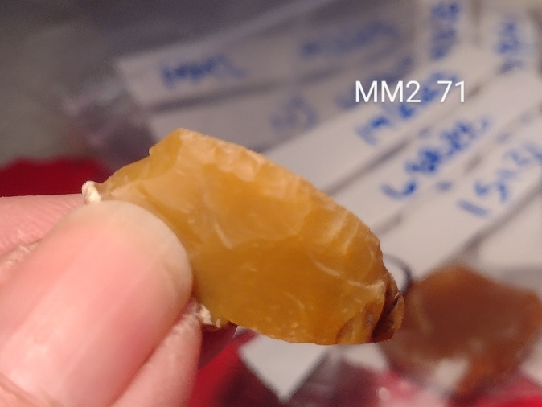
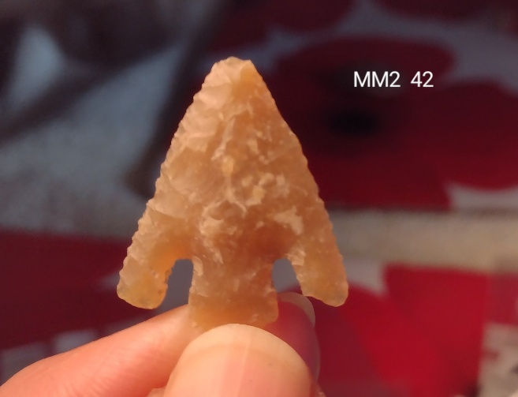
Lithics 72

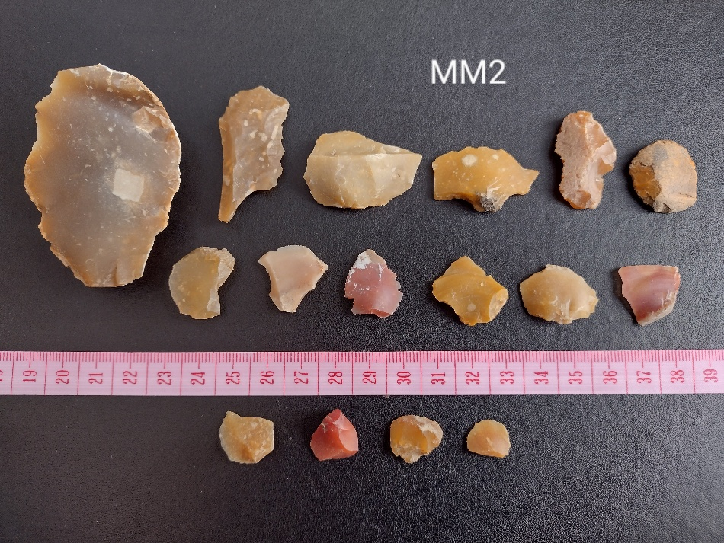

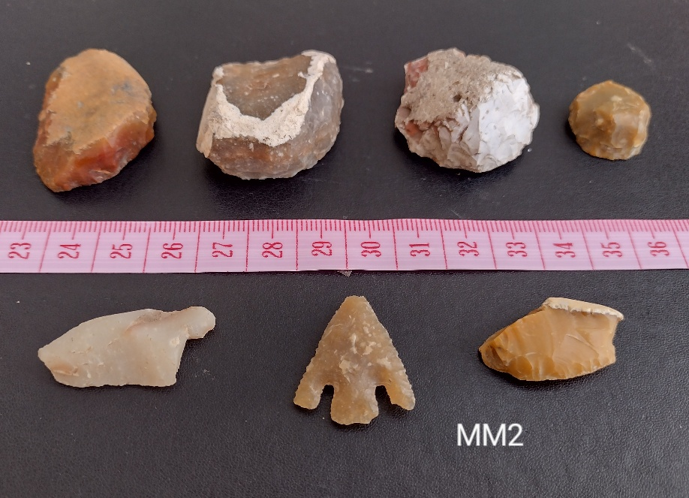

BOATLEYS BY2 22/2/25
North East BNG Ref NJ 72459 16328
South East BNG Ref NJ 72585 16199
South West BNG Ref NJ 71766 16100
North West BNG Ref NJ 71699 16342
Area Total 16ha, walked 10 ha.
Canmore Lists several crofts, and the Greatstone ( glacial erratic.)
Aberdeenshire HER As for Canmore
BGS Bedrock Kemnay Pluton - Granite, foliated-muscovite-biotite. Igneous bedrock formed between 485.4 and 443.8 million years ago during the Ordovician period.
BGS Superficial Glen Dye Silts Formation - Clay, silt and sand. Sedimentary superficial deposit formed between 116 and 11.8 thousand years ago during the Quaternary period.

Underfoot Well weathered, furrows visible, fairly dry, little midden debris, pottery etc.
Soil Loamy, not many stones.
Weather Sunny, breezy
No. of Volunteers 10 , walked E-W with furrows.
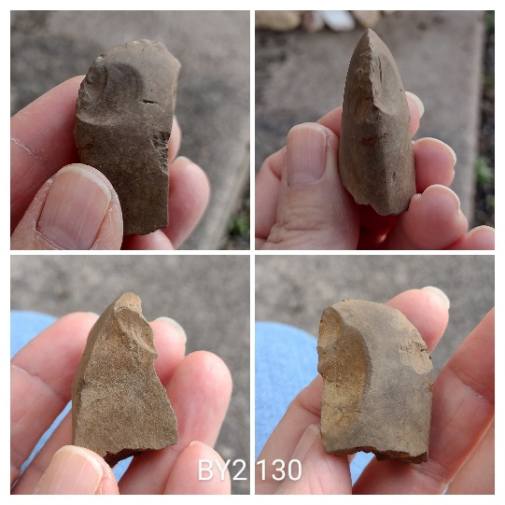
Lithics 81 Total lithics 2024+2025 = 183.

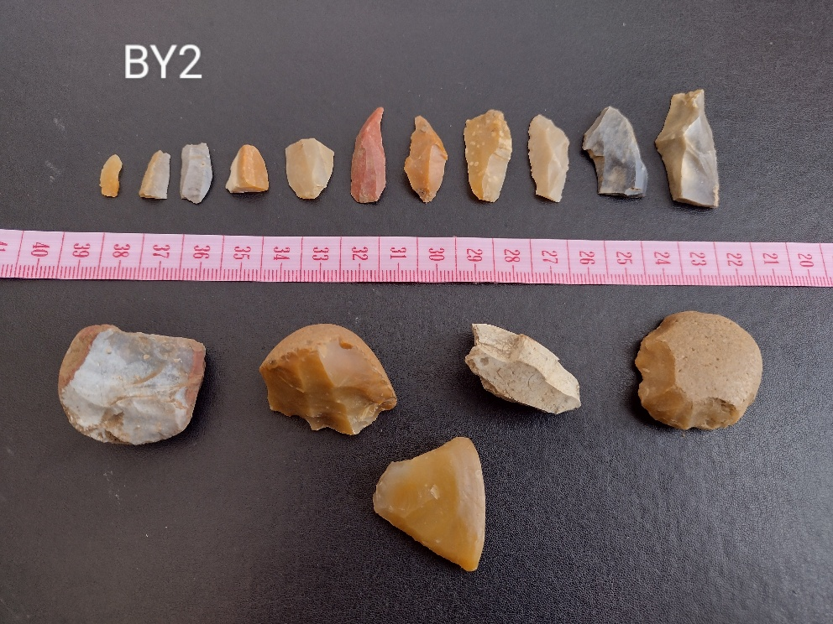

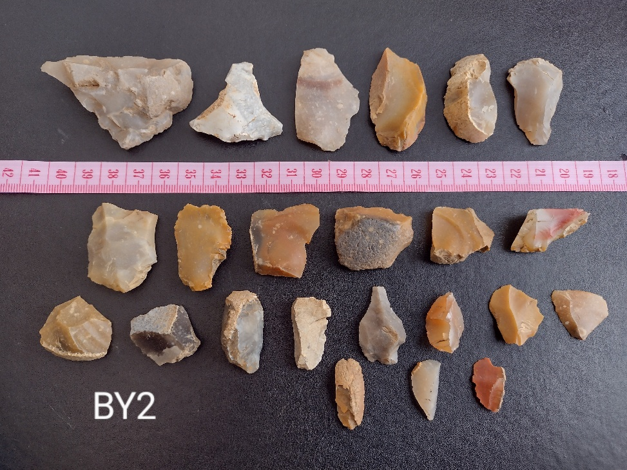

Whitehaugh WGH1 2/03/25
North East NJ 59259 17895
South East NJ 59287 17635
South West NJ 59091 17635
North West Grid Ref: NJ 59049 17892
Area 5.3ha
Bedrock geology
Craigievar Formation - Psammite, semipelite and pelite. Metamorphic bedrock
Superficial deposits
Upper 10% - Till, Devensian - Diamicton. Sedimentary superficial deposit
Lower 90% - River Terrace Deposits - Gravel, sand, silt and clay.

Canmore and HER - Nil of note.

Underfoot Mainly dry
Soil
Weather Sunny, clear
No. of Volunteers 17, walked E/W
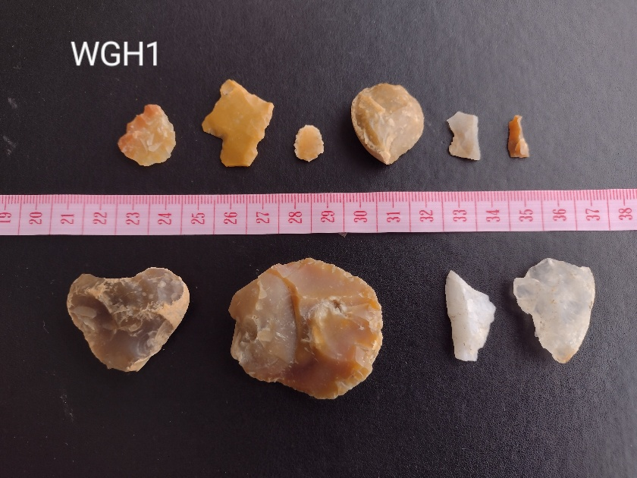
Lithics 10

Whitehaugh WGH2 2/03/25
North East NJ 59440 17903
South East NJ 59433 17638
South West NJ 59299 17633
North West NJ 59273 17899
Area Walked 2.4ha of 3.75ha
Bedrock geology
Craigievar Formation - Psammite, semipelite and pelite. Metamorphic bedrock
Superficial deposits
Upper 10% - Till, Devensian - Diamicton. Sedimentary superficial deposit
Lower 90% - River Terrace Deposits - Gravel, sand, silt and clay.

Canmore and HER - Nil of note.

Underfoot Mainly dry
Soil Sandy, clay, likely lacustrine or similar
Weather Sunny, clear
No. of Volunteers 17, walked N/S
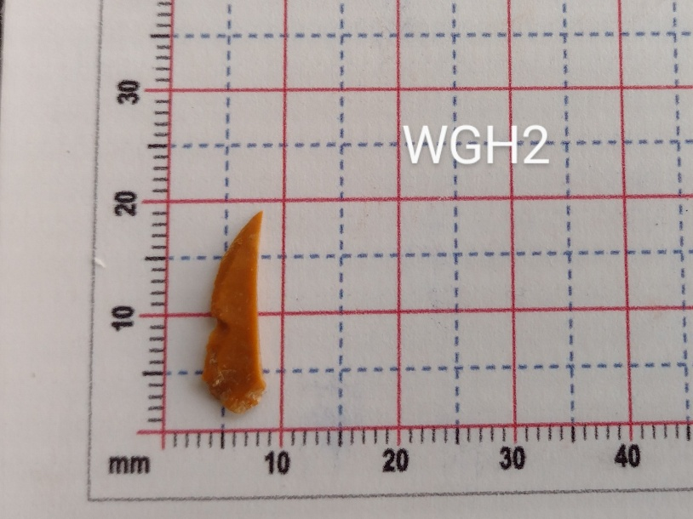
Lit

NETHER COULLIE NC1 16/3/25
North East NJ 71285 16015
South East NJ 71407 15557
South West NJ 71237 15556
North West NJ 71061 15945
Area Walked 4.3 ha of total 9.5ha
Canmore/HER Nil in this field. Probable recumbent stone circle in field to west.
BGS Bedrock Tillyfourie Pluton - Igneous bedrock

BGS Superficial Western 2/3 - Banchory Till Formation
Eastern 1/3 - Glaciofluvial Sheet Deposits - Gravel, sand and silt
Underfoot Dry
Soil Stoney soil, considerable midden pottery
Weather Overcast
No. of Volunteers 6, walked N/S with furrows
Lithics 17

NETHER COULLIE NC1, day 2 22/3/25
Underfoot Well weathered, slightly damp
Soil Stoney soil, considerable midden pottery
Weather Very overcast with intermittent drizzle and light rain.
No. of Volunteers 4 , walked N/S with furrows
Lithics 22

Nether Coullie 1
Total area walked 8.75ha ( of 9.5)
Total lithics 39
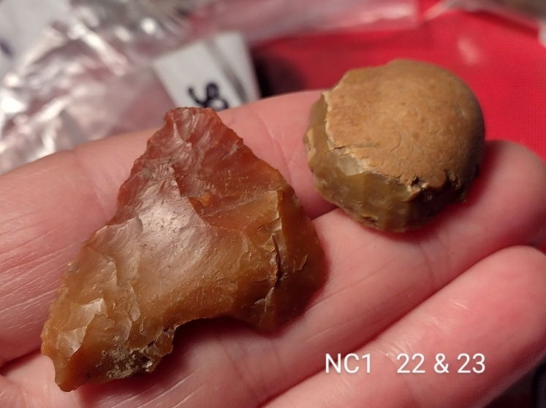

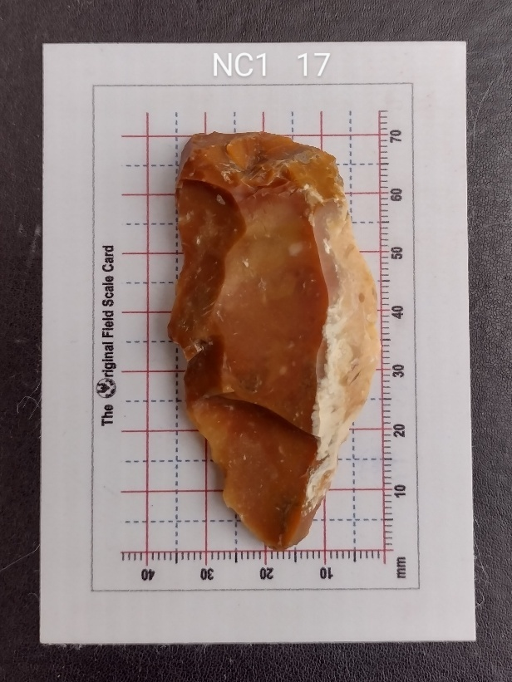

FETTERNEAR, BEHIND WALL. FBW1 5/4/25
North East NJ 72314 16662
South East NJ 72427 16376
South West NJ 72039 16402
North West NJ 72076 16623 Centroid NJ 72247 16516
Area Walked 6.3 of 7ha
Canmore and HER Nil in this field. Surrounded by created landscape for Fetternear House. Rig and furrow in wood belt to south.
BGS Bedrock Kemnay Pluton - Granite, foliated-muscovite-biotite. Igneous bedrock
BGS Superficial Northern 25% - Alluvium - Clay, silt, sand and gravel. Sedimentary superficial deposit formed between 11.8 thousand years ago and the present.
Southern 75% - Glen Dye Silts Formation - Clay, silt and sand. Sedimentary superficial deposit formed between 116 and 11.8 thousand years ago.
Underfoot Very dry, sandy. Lower part in north was solid, high baked furrows. Difficult to walk.
Soil Sandy, significant white quartz
Weather
No. of Volunteers 10 , walked N/S with furrows
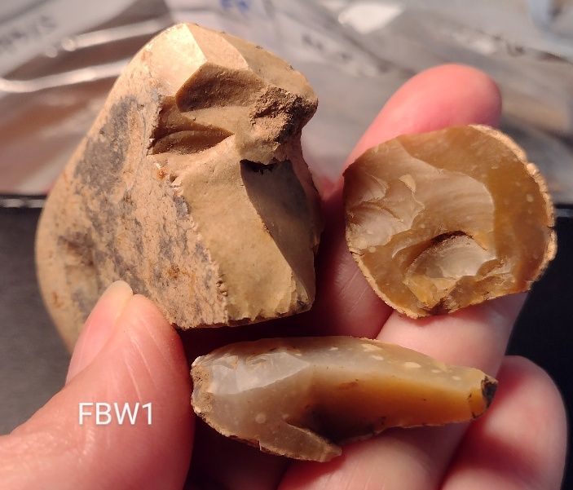
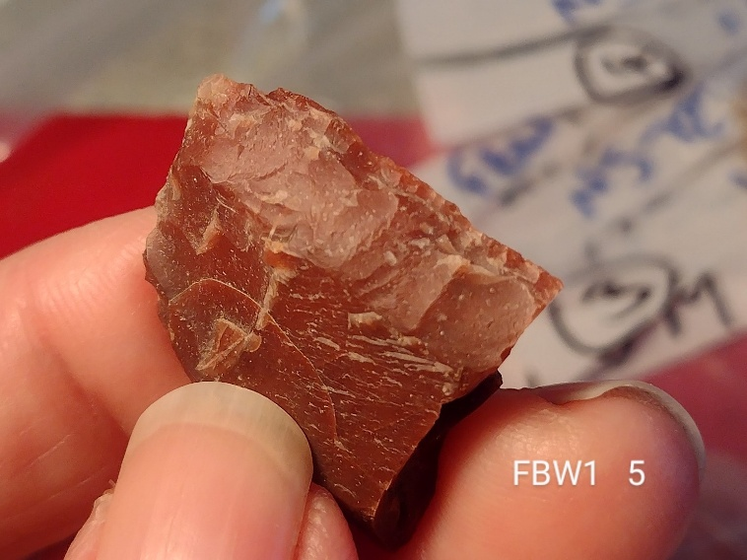
Lithics 41

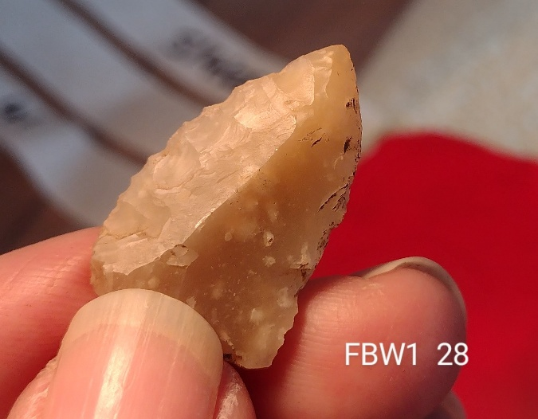

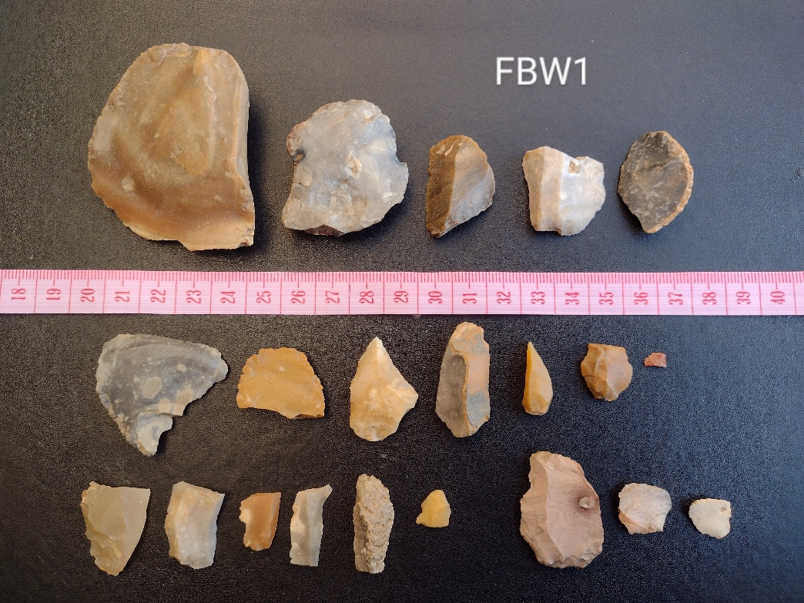

NAME DATE
North East BNG Ref
South East BNG Ref
South West BNG Ref
North West BNG Ref
Area
Canmore
Aberdeenshire HER
BGS Bedrock
BGS Superficial
Underfoot
Soil
Weather
No. of Volunteers , walked
Lithics

NAME DATE
North East BNG Ref
South East BNG Ref
South West BNG Ref
North West BNG Ref
Area
Canmore
Aberdeenshire HER
BGS Bedrock
BGS Superficial
Underfoot
Soil
Weather
No. of Volunteers , walked
Lithics

